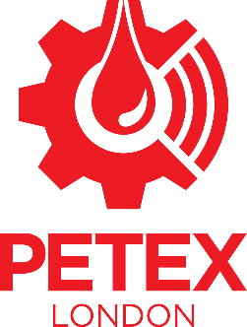

Dear [Manager Name],
I would like to attend PETETX 2020 Conference, 24 – 26 November 2020 at the Business Design Centre, London.
PETEX is the largest subsurface focused global E&P conference and exhibition in the UK. Complementing the technical conference, over 6500m2 of exhibition space will feature industry operators, service companies, national oil companies, financial companies and professional organisations. With a technical programme primed to discuss the latest global activity in exploration, field development, reservoir management and unconventional exploitation, and numerous opportunities for networking, PETEX’s audience reflects its high quality, technical conference content. The talks I am particularly interested in attending are:
……………………………………..
…………………………………..
……………………………………………
I will be able learn about the latest development, discuss and evaluate technical workflows and develop business relationships, that will support my personal development and can be implemented to improve my productivity in my day-to-day work.
The full registration rate for this conference is [insert rate selected]. As the conference is based in London I will not require overnight accommodation / I will able to secure a competitive rate at one of the official conference hotels. [Also add details of travel expenses here]. Therefore, I would like to request a budget of:
[insert requested budget]
I hope you will consider my request and grant me approval to attend.
Thank you for your consideration.
Sincerely,
[Your Name]

